Test Project Module 2
(Editorial)
WSC2013_TP40_M2_actual_EN
Submitted by: Group 2

Arnold Sandjaja ID
Christoph Elmecker AT
Hee Min Sa KR
Hjortur Gudnason IS
Katsuji Hirata JP
Michel Bulon CA
Nuno Viana PT

Introduction to test project documentation

Contents
이 테스트 프로젝트는 아래의 문서와 파일로 구성되어 있다.
This Test Project proposal consists of the following documentation/files:
- WSC2013_TP40_MOD02_actual_TP_EN.doc
- WSC2013_TP40_MOD2_PRE_EN_images (Images Folder)
- WSC2013_TP40_MOD2_PRE_EN_ATTAC_logo (ATTAC Logo Folder)
- WSC2013_TP40_MOD2_PRE_EN_BARCODE.eps
- WSC2013_TP40_MOD2_PRE_EN_TEXT_FILES.docx

Introduction
Project :
Task 1: Create a masthead for the magazine with the name “SPANNER in the works” for the organisation ATTAC
Task 2: “Design a magazine SPANNER in the works

프로젝트:
과제 1: ATTAC 이라는 기관을 위한 “SPANNER in the works” 라는 이름의 매거진 마스트헤드 제작
과제 2: SPANNER in the works 매거진 제작

Description : 설명:
ATTAC is an international organization involved in the alter-globalization movement. We oppose neo-liberal globalization and develop social, ecological, and democratic alternatives so as to guarantee fundamental rights for all. Specifically, we fight for the regulation of financial markets, the closure of tax havens, the introduction of global taxes to finance global public goods, the cancellation of the debt of developing countries, fair trade, and the implementation of limits to free trade and capital flows.

ATTAC는 ATTC는 글로벌화(globalization)에 따른 부정적 효과를 반대하는 국제적 단체로, 이들은 신자유주의를 반대하며 사회적, 생태적, 민주적인 대안을 찾아 모두의 기본적 권리를 보장하고자 하는 단체이다. 특히 경제시장 제재, 조세 피난지(tax haven) 폐쇄, 공공재 지원을 위한 국제 세금법 도입, 개발도상국의 부채 탕감, 공정거래, 자유무역과 자본유입 제한의 실행을 위해 싸우고 있다.

A word on our history
The ‘Association pour la Taxation des Transactions financière et l'Aide aux Citoyens’ (Association for the Taxation of financial Transactions and Aid to Citizens) was founded in France in December 1998 after the publication in the Monde Diplomatique of an editorial entitled ‘Désarmer les marchés’ (Disarm the markets) that launched the notion of creating an association to promote the Tobin tax.
ATTAC의 역사
토빈세(Tobin Tax)를 옹호하는 협회를 만들고자 하는 움직임을 보여줬던 Monde Diplomatique지의 ‘시장을 무장해제시키자’라는 제목의 사설이 발표된 후 1998년 프랑스에서 금융거래 과세와 시민을 위한 지원 협회가 설립되었다.

An international organization
The organization expanded very rapidly around the world with an ATTAC network around an international charter set up in 1999. Today, the association is active in some 40 countries, with over a thousand local groups and hundreds of organizations supporting the network.

국제적기관인 ATTC
ATTC는 1999년 발표된 선언문을 바탕으로 세계적인 네트워크를 통해 전 세계로 급속히 확장되었다. 현재 이 기관은 수 천 개의 지역 단체와 수 백 개의 기관의 지원을 받아 세계적인 네트워크를 형성하고 있으며 이를 바탕으로 약 40여 개의 나라에서 활발히 활동하고 있다.

Target market:

Young people between 16-35 years who are interested in the alter-globalization movement, which emphasizes values such as democracy, social and economic justice, environmental protection and human rights as an alternative to the current globalism.
They are either a member of ATTAC or are thinking of joining.

타겟마켓:
글로벌화(globalization)에 따른 부정적 효과에 대한 반대 운동 (민주주의, 사회적, 경제적인 정의, 환경보호와 인권에 대한 가치를 강조) 에 관심이 있는 16~35세 사이의 젊은이들, ATTAC의 회원이거나 가입을 하고자 하는 회원

Description of project and tasks

TASK 1
Creation of a masthead
- Create a masthead and use the name “SPANNER” with the subhead “in the works”.
- You are free to add any elements or illustrations of your own to the masthead.

Technical specifications
Trapping : 0.35 pts (if necessary).
Printing : Sheet-fed offset.

You must deliver
- 1 version of the masthead in exactly 2 PMS C colours in eps or AI format
- 1 version of the masthead converted to CMYK in eps or AI format
- 1 version of the masthead in Adobe RGB (1998) for the web in JPG format
- 1 file PDF/X-4:2008 file of the masthead in CMYK on one single A4 sheet at both 15cm wide and 4cm wide (without any marks, bleed or colour bars)
- 1 Printout masthead and mounted on cardboard from the CMYK PDF/X-4:2008 file

- 과제 1:
마스트헤드 제작
- 마스트헤드를 제작하고 “SPANNER”와 (“in the works”는 작게) 라는 명칭을 사용해야 한다
- 선수는 마스트헤드 제작에 있어 어떠한 요소 또는 본인이 제작한 일러스트레이션을 자유롭게 사용할 수 있다

기술적 사항
트래핑: 0.35 pts (필요한 경우)
인쇄: sheet-fed offset

선수가 반드시 해야 할 것:
- 정확하게 2PMS C 컬러로 eps 또는 AI 포맷의 마스트헤드버전 1개
- CMYK로 전환한 eps 또는 AI 포맷의 마스트헤드버전 1개
- 아도비 RGB(1998) 로 만들어진 웹을 위한 JPG 포맷의 마스트헤드버전 1개
- CMYK로 만들어진 PDF/X-4:2008 마스트헤드의 파일 1개, A4 용지 한 장에 15cm와 4cm 크기로 제작 (어떠한 마크나 블리드 또는 컬러바가 있어서는 안 된다.)
- CMYK PDF/X-4:2008 마스트헤드의 파일 인쇄물 1개를 카드보드에 마운팅한다

TASK 2
Magazine Design
- Create a design for the front cover, back cover and spine
- Create a design for page 3 of the magazine accommodating for the die-line of the cover
- Create two spreads for the magazine (pages 8&9, 10&11)
- Include required text in the magazine (WSC2013_TP40_MOD2_PRE_EN_TEXT_FILES.docx)
- You must create a die-line for the cover
- The inside pages of the magazine will be printed in 2 colours (Black and PMS 7549 C)
- Include the barcode with a white background; do not resize it and make sure it’s 100% black (WSC2013_TP40_MOD2_PRE_EN_BARCODE.eps)
- You may create your own illustrations

과제 2: 매거진 디자인
- 앞표지, 뒷표지와 책등 (스파인) 을 제작한다.
- 매거진의 3페이지를 디자인한다. 이 페이지는 앞표지의 다이라인과 겹쳐지는 부분이다.
- 매거진 스프레드 2장을 제작한다. (8-9 페이지, 10-11페이지)
- 매거진에 필수 텍스트를 포함한다. (WSC2013_TP40_MOD2_PRE_EN_TEXT_FILES.docx)
- 앞표지에 다이라인을 반드시 제작한다.
- 매거진 내부는 2개의 컬러로 인쇄한다 (블랙과 PMS 7549 C)
- 흰 배경에 바코드를 포함한다; 크기는 재조정하지 말고, 100% 검정색으로 제작한다. (WSC2013_TP40_MOD2_PRE_EN_BARCODE.eps)
- 선수는 본인만의 일러스트레이션을 제작할 수 있다.

Front Cover must include:
- Masthead
- Selling Line
- Logo %ATTAC
- Main cover line
- image (at least one)
- 3 Cover lines
- Dateline
- Barcode
- Splash/ Seal/ Flash/ Slashes
- Any other artwork you deem necessary

앞표지에 반드시 포함할 요소
- 마스터헤드
- 셀링 라인
- 로고 %ATTAC
- 주요기사제목 (거의 표지의 1/4 정도를 차지)
- 이미지 (최소 1개 이상)
- 3개의 커버라인
- 날짜 기입선 (Dateline)
- 바코드
- 스플래시/씰/플래시/슬래시
- 선수가 필요하다고 생각하는 다른 종류의 일러스트레이션 (artwork)

Back Cover must include:
- The logo at exactly 35mm wide
- Text for back cover
- Any other artwork you deem necessary

뒷표지에 반드시 포함할 요소
- 정확히 35mm 크기의 로고
- 뒷표지의 텍스트
- 선수가 필요하다고 생각하는 다른 종류의 일러스트레이션 (artwork)

Spine must include:
- Text for spine

책등 (스파인)에 반드시 포함할 요소
- 책 등의 텍스트

Inside pages of the magazine must include:

- Page 3: Single page must display an editorial with titles, texts, and caption (at least 1 image and any other artwork you consider necessary)
- Page 8-9: One spread must display the cover story and some images of the cover story (at least 2 images) with titles, texts, captions, 1 table and 1 infographic
- Page 10-11: One spread must display three short articles with titles, texts, and captions (at least 1 image for each article)

잡지 내부에 반드시 포함할 요소
- 3 페이지: 한 장의 페이지에는 반드시 에디토리얼을 포함하고, 타이틀, 텍스트, 캡션을 반드시 포함해 제작한다. (적어도 1개의 이미지나 선수가 필요하다고 생각하는 이미지를 포함)
- 8-9 페이지: 한 장의 스프레드에는 반드시 커버스토리와 이와 관련된 이미지를 반드시 포함해 디자인한다. (최소한 2개의 이미지와 타이틀, 텍스트, 캡션, 표 1개, infographic 1개를 포함해 디자인한다.
- 10-11 페이지: 한 장의 스프레드에는 3개의 짧은 기사 (1개의 기사 당 최소한 1개의 이미지를 사용)를 사용해 디자인한다. 타이틀, 텍스트, 캡션을 포함한다.

Technical specifications
Dimensions : A maximum page size of 190mm x 270mm (portrait) perfect bound with a 6 mm spine.
Paragraph Styles : Must be used for titles, body text, caption
Character Styles : Must be used for coverline, Dateline
Master Page Elements : Header/footer and page numbers
Bleed : 3 mm
Colours (Front, spine & Back cover) : CMYK, spot dieline
Colours (inside pages of magazine) : 2 colours (PMS 7549 C and Black)
Output ICC profile in PDF : ISO Web coated FOGRA28 /Total ink 300% (front & back Cover) 200% (inside pages of magazine)
Printing system : Heatset web offset
Dieline : Must be named “Dieline”, must be created as a spot colour and must overprint
Greyscale and colour images resolution : 262 to 350 PPI at 100% in InDesign
Bitmap images resolution : 800 to 1200 PPI at 100% in InDesign

기술적 사항:
- 크기: 최대 190mm X 270mm (portrait) 사이즈의 페이지는 6mm 높이의 책등을 이용하여 완벽하게 제작되어야 한다.
- 문단 스타일: 반드시 타이틀, 본문, 텍스트, 캡션을 사용
- 캐릭터 스타일: 주요 기사 제목 (커버라인)과 날짜 기입란(Dateline)에 사용
- 마스터페이지에 들어갈 요소: 헤더, 꼬리말(footer), 페이지 넘버
- 블리드: 3mm
- 컬러 (앞&뒷표지, 책등): CMYK, 스팟 다이라인
컬러 (내부): 2개의 컬러 (PMS 7549 C 와 검정)
- PDF 내의 Output ICC Profile: ISO Web Coated FOGRA28 / Total ink 300% (앞뒷표지) 200% (내부)
- 인쇄 시스템: Heatset web offset
- 다이라인: 반드시 “Dieline”으로 지정, 별색 (스팟 컬러)으로 제작하고, 오버프린트가 되어야 한다.
- 그레이스케일과 컬러 이미지 해상도: 인디자인(InDesign)에서 100%, 262에서 350 PPI로 제작
- 비트맵 이미지 해상도: 800 에서 1200 PPI
- 이미지를 위한 ICC Profi-

    - You must deliver (선수가 반드시 해야 할 일)

• 1 final folder for archiving named with your competitor number_module1
(including native files, fonts, linked images, ICC profile and the press ready PDF/X1a file)
only files from this folder will be marked

(원본파일, 폰트, 링크된 이미지, ICC profile 과 인쇄 가능한 PDF/X1a 파일을 포함한) 최종 폴더는 “선수번호_module1”로 저장되어야 한다. 이 폴더에 저장된 파일만 채점된다.

• 2 final press ready PDF/X1a files (1 PDF for cover, spine and back cover; and 1 PDF for inside pages, including: bleed, crop marks, registration marks, fold marks — placed outside the bleed area, colour bars for CMYK, colour bar PMS C, dieline on a separate plate in the PDF, to be evaluated in the PDF file)

인쇄 가능한 2개의 PDF/X1a 파일 (앞뒷표지와 책등 PDF 파일 1개와 내지 PDF 파일 1개)
(블리드, 크롭마크, 레지스트레이션 마크, 폴드 마크를 포함해야 하며 폴드파크는 블리드 영역 밖에 위치한다. CMYK 컬러바, PMS C 컬러바를 포함한다.
다이라인은 별개의 PDF 플레이트에 저장하며, PDF 파일로 평가한다. )

• 1 final printout untrimmed and mounted on cardboard : the front cover, spine and back cover with the die-line (printed as spreads). (including: bleed, crop marks, registration marks, fold marks — placed outside the bleed area, colour bars CMYK)

untrimmed되고 카드보드에 마운팅된 1개의 최종 인쇄물: 스프레드로 인쇄된 다이라인을 포함한 앞표지, 책등, 뒷표지 (블리드, 크롭마크, 레지스트레이션 마크, 폴드 마크를 포함해야 하며, 이것들은 블리드와 CMYK 컬러바 영역 밖에 위치해야 한다.)

• 1 final printout of: the die-line (printed as spreads). (including:, crop marks, registration marks, fold marks — placed outside the bleed area)

스프레드로 인쇄된 다이라인 최종 인쇄물 1개: (블리드, 크롭마크, 레지스트레이션 마크, 폴드 마크를 포함해야 하며 이것들은 블리드 영역의 밖에 위치한다.

• 1 final dummy/booklet trimmed to final size including:
- the front cover, spine, back cover printed as spreads
- 1 page printed as a single page (page 3)
- four pages printed as spreads (8-9 and 10-11)

1개의 샘플/북렛은 최종사이즈로 트림하며 아래의 사항을 포함한다:
- 앞, 뒷표지, 스파인은 스프레드로 인쇄한다
- 1장은 싱글 페이지로 (한장) 인쇄한다 (3페이지)
- 4장의 페이지는 스프레드로 인쇄한다 (8-9, 10-11 페이지)

- Instructions to the competitor (선수 공지사항)
Create a folder on your Desktop called YY_MODX (where YY represents the number of your workstation). This folder must include the following subfolders:

YY_MODX (YY는 작업장소 번호) 란 이름으로 데스크톱에 폴더를 만든다. 폴더에는 하단의 부폴더 (subfolder)를 반드시 포함해야 한다.

- Original_folder: it should contain all the files used for the development of your project, properly organized (fonts, links, etc.).
- Final_folder: it should contain all the files you are supposed to deliver as required in the tasks (PDF, etc.).

1. 원본 파일: 선수가 과제에 사용했던 모든 파일을 포함해야 한다. 이 파일들은 정리가 되어있어야 한다. (폰트, 링크 등)
2. 최종 파일: 과제에서 요구했던 최종 모든 파일을 포함해야 한다. (PDF 등)

About image marking for the tasks: (과제물 중 이미지와 관련된 채점 관련)

The colour mode and file formats of your images will be evaluated in the press ready PDF files. The final resolution will be assessed in the InDesign file.
이미지의 컬러모드와 파일 포맷은 인쇄 가능한 PDF 파일에서 채점된다. 최종 해상도는 인디자인(InDesign)에서 평가될 것이다.

The JPG file format is NOT ACCEPTED for images; except for the web component of the logo in RGB for the web.
Only the following file formats are acceptable .TIF / .EPS / .AI / .PSD / DSC 2.0
이미지의 경우 JPG 포맷은 절대로 사용할 수 없다. 하지만 웹을 위한 RGB로 만들어진 로고의 경우는 제외한다.
아래의 파일 포맷만 사용 가능하다. TIF / .EPS / .AI / .PSD / DSC 2.0

About final design marking for the catalogue:
The task must be created in a page layout program (Adobe InDesign).
Images must not be embedded or placed in Adobe Illustrator or embedded in InDesign

Any file saved out of its respective folder WILL NOT BE EVALUATED.

(카탈로그 최종 디자인과 관련된 채점 관련)
이 과제는 반드시 아도비 인디자인(Adobe InDesign)의 페이지 레이아웃 프로그램을 이용해 수행한다. 이미지들은 아도비 일러스트레이터(Adobe Illustrator)에서 임베드되거나 위치할 수 없다.
각각의 폴더 외부에 저장된 파일은 채점되지 않는다.

Marking scheme (채점표)
A | Creative process 창조적 능력 (2점) |  | Subjective /2
A.1 | Idea and originality (masthead, dieline and magazine) 아이디어와 독창성이 있는가 (마스트헤드, 다이라인, 매거진) |  | 1.00
A.2 | Understanding the target market (masthead, dieline and magazine) 타겟층이 맞는가 (마스트헤드, 다이라인, 매거진) |  | 0.50
A.3 | Unity and relationship (masthead and magazine) 통일성과 관계성이 있는가 (마스트헤드와 매거진) |  | 0.50
B | Final design 최종 디자인 (8점) |  | Subjective /8
B.1 | Quality of the visual composition (masthead and magazine layout) 시각적 구성의 질이 높은가 (마스트헤드, 매거진 레이아웃) |  | 1.00
B.2 | Impact of the design (masthead, magazine layout and usage of font) 디자인의 임팩트가 있는가 (마스트헤드, 매거진 레이아웃) |  | 1.00
B.3 | Quality of the typography for the masthead 마스트헤드의 타이포그라피가 읽기 쉽고 명료한가 |  | 1.00
B.4 | Quality of the typography for the magazine 매거진의 타이포그라피가 읽기 쉽고 명료한가 |  | 2.00
B.5 | Quality of the colours for the masthead 마스트헤드의 색상선택이 적절한가 |  | 0.75
B.6 | Quality of the colours for the magazine 매거진의 색상선택이 적절한가 |  | 1.25
B.7 | Quality of the design & originality of other elements (choice of page size & master page elements) 디자인과 다른 요소의 독창성이 있는가 (페이지 크기 선택과 마스터 페이지 요소) |  | 0.50
B.8 | Quality of the infographic (magazine page 8 or 9) 인포그래픽의 질이 높은가 (매거진 8-9페이지) |  | 0.50
 | 객관적 채점항목
C | Computer usage 컴퓨터 사용능력 (4점) |  | Objective /4
C.1 | Resolution of linked images as specified in magazine marked in InDesign 인디자인에서 표시된 매거진의 링크 이미지 해상도가 정확한가 |  | 0.50
C.2 | Colour mode of linked images as specified in magazine 매거진의 링크된 이미지 컬러모드가 정확한가 |  | 0.75
C.3 | Logo and barcode dimensions as required in the task 매거진 뒷표지에 로고 크기가 요구한대로 정확한가 |  | 0.25
C.4 | Use of paragraphs styles & master pages in layout as specified in magazine 매거진의 레이아웃의 문단 스타일과 마스터페이지의 사용이 정확한가 |  | 1.00
C.5 | Use of Character Styles in layout as specified in magazine 매거진 레이아웃의 캐릭터 스타일이 정확한가 |  | 0.25
C.6 | Final dimensions of layout as specified in all tasks (masthead, spine, inside pages) 모든 과제의 레이아웃 최종 크기가 정확한가 (마스트헤드 스파인, 매거진 내부) |  | 0.50
C.7 | All required text is present (masthead and inside pages) 모든 요구된 텍스트가 쓰여졌는가 (마스트헤드와 매거진) |  | 0.50
C.8 | All required elements are present in both tasks 모든 요구된 사항이 2개의 과제에 모두 있는가 |  | 0.25
D | Manual abilities 손기술력 (2점) |  | Objective /2
D.1  D. 2 | Mounting printouts for presentation 프레젠테이션을 위한 출력물의 마운팅 상태가 적절한가  Mounting printouts for presentation and dummy 프레젠테이션과 샘플을 위한 출력물의 마운팅의 상태가 적절한가 |  | 1.00  1.00
E | Knowledge of the printing industry 인쇄산업에 대한 지식 |  | Objective /4
E.1 | Bleed value applied in PDF 블리드값이 정확하게 PDF에 적용되었는가 |  | 0.25
E.2 | Fold lines, crop mark, colour bars & registration marks supplied in PDF 접히는 선 (fold line), 크롭마크, 컬러바와 맞춰찍기 표시 (registration marks)가 PDF에 정확히 저장되었는가 |  | 1.50
E.3 | Trapping values applied in illustrator file if necessary (masthead) 필요한 경우 사용된 트래핑값이 일러스트레이터 파일에 정확하게 적용되었는가 (마스트헤드) |  | 0.50
E.4 | Correct spot & CMYK colours used and supplied in PDF file as specified in magazine 매거진에서 지정한대로 정확한 스팟칼라와 CMYK 컬러가 PDF 파일에 정확히 사용되고 저장되었는가 |  | 1.50
E.5 | Colours used in the masthead 마스트헤드의 색상 사용이 정확한가 |  | 0.25
F | Saving and file format 저장과 파일 포맷 |  | Objective /5
F.1 | All files saved in the correct format (masthead and magazine) 최종파일이 정확한 포맷으로 저장되었는가 (마스트헤드와 매거진) |  | 1.00
F.2 | ICC profile applied in images, PDF or layout file as specified in the task ICC profile이 이미지, PDF, 레이아웃에 제대로 적용되었는가 |  | 2.25
F.3 | Saving in a specified PDF format as required in the task 과제에서 요구한대로 지정된 PDF 포맷 파일로 저장하였는가 |  | 1.00
F.4 | Final production folder saved as required in the task 최종작품 폴더에 요구한대로 정확하게 저장되었는가 |  | 0.75

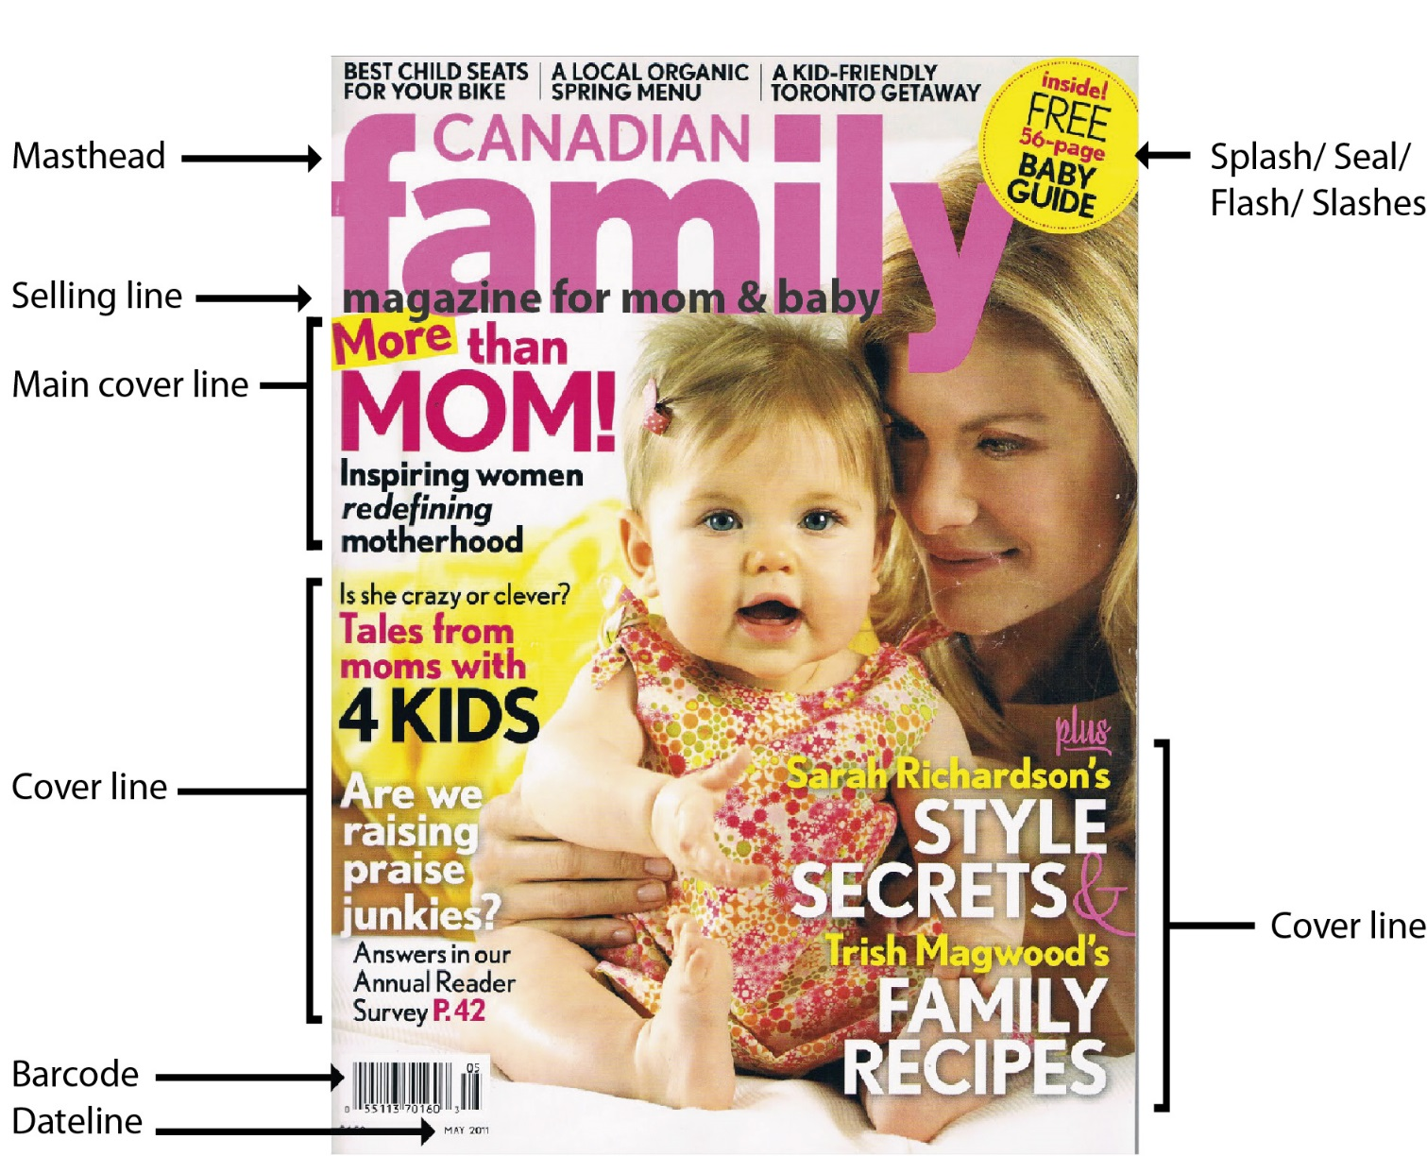

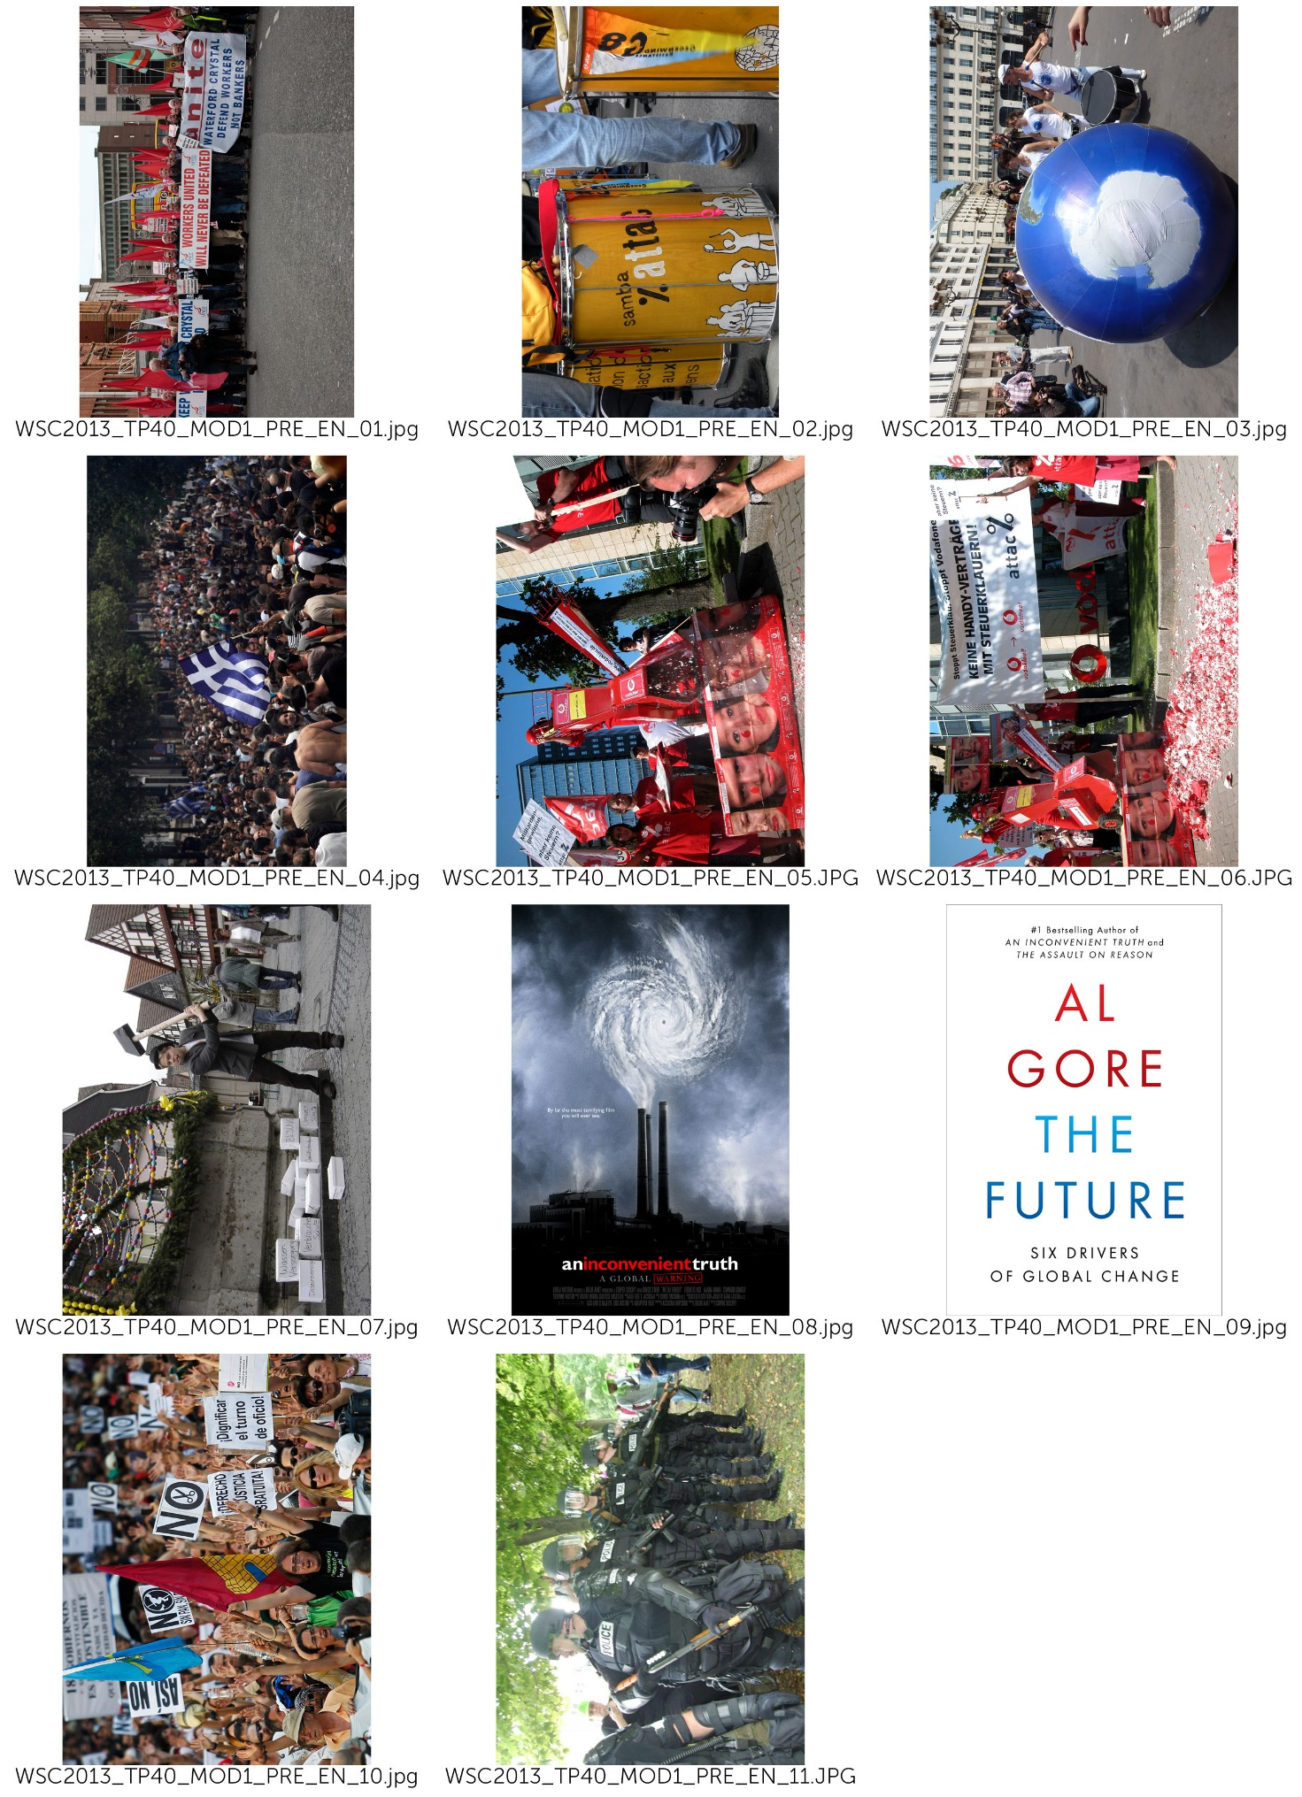
(- COVER) 커버
(use picture at your choice:
- WSC2013_TP40_MOD1_PRE_EN_01.jpg
- WSC2013_TP40_MOD1_PRE_EN_02.jpg
- WSC2013_TP40_MOD1_PRE_EN_03.jpg)

(– Masthead ) 마스트헤드

SPANNER in the works

(– Selling Lines ) 셀링라인

News magazine of ATTAC network

(– Main Line Cover) 메인 커버라인

Global Tax Justice:
If everybody shares the burden, no one suffers

(– Cover Lines) 커버라인

Fiscal and Economic Union
The Future by Al Gore
For a Europe-wide coordinated levy on wealth

(– Date Line) 데이트 라인 (날짜)

17 August 2013

(– Splash/ Seal/ Flash/ Slashes ) (스플래시)

SPECIAL EDITION

(– Back Cover) 뒷표지
(use picture:
- WSC2013_TP40_MOD1_PRE_EN_07.jpg)

( Title: ) 타이틀

We fight for

( Main text: ) 주요 본문
Attac sees the domination of financial markets on society as the main obstacle to the shift to a new mode of development that would be social, ecological, democratic, and relying on solidarity. In order to bring this domination to an end we demand:
• Limits to capital flow and regulations such as a tax on financial transactions so as to drastically reduce all speculative moves.
• The socialization of the banking sector so that the banks’ investment policies will be governed by social and ecological imperatives and not by short-term profits.
• The prohibition of any capital transit via tax havens to put an end to occult financial activities and to tax evasion.
• Restrictions to TNCs through international regulations.
• The cancellation of the public debt of developing countries.
• An increase in taxes on financial incomes and on private estates;
• A fair organization of international trade that is favourable to developing countries, wage earners, and the environment.
• Access to common goods of humankind (water, education, healthcare…) so that human rights are adhered to.
• Global taxes to finance access to common goods, namely taxes on TNC profits, polluting activities (carbon tax), on financial transactions, on large private estates.
• A social and ecological agriculture without GM, respectful of the principle of food sovereignty and making it possible for peasants to earn a decent living both in the North and in the South.
• Ways of solving conflicts peacefully (Attac favours non violence in its actions).
Attac also fights any extension of commodification, whether through privatization of public services, the development of pension funds, the privatization of social security, speculation on the right to pollute through a carbon market.

(– Master Pages) 마스터페이지

SPANNER in the works

(– Page numbers ) 페이지 번호

3, 8, 9, 10, 11

(– Spine ) 책등

SPANNER in the works

17 August 2013

(– PAGE 3) 3 페이지

(Title: ) 타이틀
Our ideas

(Main text: ) 본문 텍스트
Attac is a movement opposing neo-liberal globalization
Neo-liberal globalization, based on the ‘liberalization’ of trade and financial markets, started at the end of the 1970s and has led to the total domination of financial markets on society as a whole. It is an instrument designed to further the enrichment of a tiny minority of investors at the expense of the rest of the population and the planet. Its effects are detrimental to.

Social rights

neo-liberal globalization facilitates the shipping of businesses and jobs out of the country and fosters the worldwide competition between workers and, consequently, their precarization ;
It covers up tax evasion thanks to tax havens and sets in motion the competition between national tax systems and thus the reduction of public services.

The planet

Neo-liberal globalization makes it possible for transnational companies to spread their production on the surface of the globe based solely on costs, so that the various parts of a product can be manufactured at different locations on the planet, generating thousands of miles of transport;
It sets up a competition between national environmental regulations and thus pushes them to the lowest possible level;
It tends to commercialize all aspects of society and thus extends endlessly the consumer and growth society.

North South solidarity

As it organizes tax evasion, neo-liberal globalization imposes a new form of colonialism through corruption of elites in countries of the South;
Through free trade it imposes competition between farmers in the South and the large agro-business owners of the North ;
Via the debt mechanism, it allows the World Bank and the IMF to impose massive deregulation policies on developing countries.

Democracy

WTO, IMF, World Bank and the European Union set up new global economic rules outside any democratic debate: most international negotiations on trade or financial regulation occur away from the people; Neo-liberal globalization promotes the concentration of information dissemination in the hands of a few media and internet conglomerates.
The commercialization of all spheres of society reduces people to mere consumers at the expense of their citizenship.
And so, over the past 30 years we have witnessed a substantial enrichment of capital holders to the detriment of the vast majority of wage earners, together with a continued deterioration of the condition of our planet.
In the OECD countries, the proportion of wage earners in the producing sectors has declined by 10% while the return to capital has risen since the mid-1970s. In the United States, for instance, 60% of the growth recorded since 1980 has been captured by the wealthiest 1%.

(Caption for the pictures in this article : use picture at your choice:
사진을 위한 캡션: 사진은 선수가 마음대로 사용할 수 있다
- WSC2013_TP40_MOD1_PRE_EN_03.jpg
- WSC2013_TP40_MOD1_PRE_EN_05.jpg
- WSC2013_TP40_MOD1_PRE_EN_06.jpg)

Neo-liberal globalization promotes the concentration of information dissemination.

(– Pages 8 and 9) 8-9 페이지

(Title: ) 타이틀
Global Tax Justice:
If everybody shares the burden, no one suffers.

(Main text: ) 본문

How did this come about?

In the sixties and seventies capital was not very mobile, a tight net of capital transfer controls hampered the free flow of the deutschemark, schilling, pound etc. Due to this limited opportunities for capital flight taxation was reasonably fair. At this time the economy boomed, it grew faster than in the previous twenty years, full employment was close by and the differences in incomes began to shrink slowly. This scenario changed at the end of the seventies when neo-liberal politics like Thatcherism and Reaganomics got established worldwide. One of the core elements of neo-liberalism is the free flow of capital, but once capital is totally free to move it is difficult for Finance Ministers to tax it accordingly.

More and more Tax Havens

It gets even more difficult when, in the course of liberalisation, tax havens appear. You find tax havens not only in the Caribbean or Pacific (Bahamas, Samoa) but also right in the middle of Europe - Luxembourg, Liechtenstein, Monaco, Switzerland and Austria. In tax havens capitals gains and financial wealth are not only save from taxation, but the financial authorities in the countries of origin don´t get informed because of bank secrecy. The result is that the profiteers of globalisation contribute less and less to our common goods - hospitals, education, public transport, environmental protection, sport and culture.

Tax Competition Begins

Tax havens not only attract tax evaders, they also put pressure on other countries to reduce their tax rates on income, profit and wealth. In the last twenty years almost all countries have been competing in reducing taxes on income, profits, and capital gains. In the industrialised countries the average tax on business profits has dropped from 51% to 35% since 1985. Tax on interest yield from 47% to 33% and the top income tax bracket plummeted from 52% to 42%, and this process is by no means at an end. Indeed some economists consider that in the long run it won't be possible to tax profits at all. For some multinational corporations this is already the case - they file their profit tax returns in tax havens, they use tax loopholes or sometimes even manipulate their balance sheets. The result is they pay little or no tax where they are actually operating. Some examples for Austria: Creditanstalt (1998 and 99) the Spar AG (1997 and 98) and Shell Austria (1977) or the Immuno AG (1977). This is not just unfair for the community, but also for the small and midium sized businesses that can´t use these 'creative possibilities' and suffer under an unfair competitive disadvantage.

(Caption for the pictures in this article : use picture at your choice:
사진을 위한 캡션: 사진은 선수가 고를 수 있다
- WSC2013_TP40_MOD1_PRE_EN_01.jpg
- WSC2013_TP40_MOD1_PRE_EN_02.jpg
- WSC2013_TP40_MOD1_PRE_EN_03.jpg)

One of the core elements of neo-liberalism is the free flow of capital.

(- INFOGRAPHIC) 인포그래픽

(title) 타이틀
Reduction of tax rates on income, profit and wealth In the industrialised countries

(text) 텍스트
The average tax on business profits has dropped
51% to 35%

Tax on interest yield
47% to 33%

The top income tax bracket plummeted
52% to 42%

(caption for infographic) 인포그래픽 캡션
Since 1985

( -TABLE) 표

(title) 타이틀
The multinational corporations who pay little or no tax

(text) 텍스트
Company Year
Creditanstalt 1998,1999
Spar AG 1997, 1998
Shell Austria 1977
Immuno AG 1977

(caption for table) 표 캡션
Some examples for Austria

(– Pages 10 and 11) 10-11 페이지

(Title: ) 타이틀

The Future by Al Gore – review.

(Main text: ) 본문

Al Gore's alarming new guide to what needs to change in world politics is essential reading
According to reliable reports, the new leadership in Beijing has been reading Alexis de Tocqueville. It's not hard to see why China's elite might look for guidance to the aristocratic French thinker. In his classic text The Ancien Regime and the Revolution (1856), de Tocqueville wrote that the danger of revolution is not greatest in the depths of poverty and despair but when conditions have been improving – especially if some are benefiting far more than others. The relevance of this for China is obvious. The implications for policy are rather less so, since de Tocqueville also warned that for a bad government, the moment of greatest danger comes when it starts to reform. In such circumstances, repression might be a more prudent course of action. This troubling ambiguity could explain why Chinese readers, struggling to decipher the intentions of their rulers, made de Tocqueville's book a national bestseller.
From a parochial British perspective, what might be most significant is the fact that China's rulers are reading de Tocqueville at all. It is difficult to imagine David Cameron devoting any time to a 19th-century thinker. Along with much of the political class, the prime minister seems resistant to the notion that history has anything to teach, and looks for guidance to writers who extol the wisdom of crowds, explain the momentous importance of tipping points or pass on the revelation that humans are social animals – the fleeting nostrums of the airport bookstore. But if our rulers will not read the classics then they must read Al Gore, who, after eight years of reading and thinking, has produced a guide for the politically perplexed that will surely endure.

(Caption for the pictures in this article : use picture at your choice:
사진을 위한 캡션: 사진은 선수가 고를 수 있다
- WSC2013_TP40_MOD1_PRE_EN_08.jpg
- WSC2013_TP40_MOD1_PRE_EN_09.jpg)

The Cover of Al Gore’s Book, The future

(Title: ) 타이틀

For a Europe-wide coordinated levy on wealth

(Main text: ) 본문

The nature of the crisis
A constantly increasing disparity of wealth is an intrinsic aspect of capitalism. Wealth grows faster than workers’ income. Large amounts of wealth grow faster than small amount. In some countries, wealth taxes exist. But the tax rates are much lower than the growth rates of large fortunes. Therefore, strong political correctives to create a fairer distribution are necessary. This applies even more in the currently dominant form of capitalism driven by financial markets, since here the disparity in the distribution of prosperity has been growing especially rapidly. As this polarization of the distribution of wealth grows, so does the amount of capital circulating around the world in search of profitable investment opportunities. In particular since the 1970s, this mass has increased dramatically. It became less and less possible to exploit this capital profitably in the productive economy. In the search for new sources of profit, the international financial markets became more and more important. This transition was accompanied and fostered by constantly increasing deregulation and globalization of the financial markets, and led to a quite novel dynamism involving the polarization of the distribution of income and assets. The increasing dominance of the financial markets has allowed gigantic profits – and also losses – to be made within seconds. Thus the system is becoming more and more unstable. More and more speculative bubbles develop, which must burst sooner or later.

(Caption for the pictures in this article : use picture at your choice:
사진을 위한 캡션: 사진은 선수가 고를 수 있다

- WSC2013_TP40_MOD1_PRE_EN_10.jpg
- WSC2013_TP40_MOD1_PRE_EN_11.jpg)

A constantly increasing disparity of wealth is an intrinsic aspect of capitalism

(Title: ) 타이틀

Fiscal and Economic Union

(Main text: ) 본문

Fiscal pact, ESM, six-pack, two-pack
Under the pressure of the crisis, the powerful are pushing through their murky "reform" measures at a rapid pace. The logic is always the same: Reduce debts through cuts in social services and privatisation, raise competitiveness through wage cuts and eliminate workers rights. The consequences: A deep recession, further aggravating the economic crisis. In southern Europe the 'Troika' of the ECB, EU Commission, and the IMF dictate one so called Memorandum (austerity package) after another. The reality is a devastating social crisis. Mass unemployment, poverty, homelessness, soaring crime and waves of suicides are once again part of European everyday life. And "coincidentally" our democracies are being hollowed out: highly indebted countries are forced to transfer their sovereignty from their elected parliaments to the EU. Every day, the technocrats of the EU Commission and the ECB gain yet more power for themselves.
Can things get even worse, after all the reform packages so far that have established a neo-liberal, anti-democratic politics throughout Europe? Yes they can. In the European Council the introduction of a fiscal and economic union is being prepared right now. The diktat of austerity, through which Greece, Spain and Portugal suffer right now, will be institutionalised on the European level. Or as the European Commission President Barroso put it: A quiet revolution has been taking place.

(Caption for the pictures in this article : use picture:
- WSC2013_TP40_MOD1_PRE_EN_04.jpg)
사진을 위한 캡션: 사진 사용

In the European Council the introduction of a fiscal and economic union is being prepared.

